**Power Supply**

The power supply is designed to supply power to the Beagle Bone. It utilizes a linear regulator which takes in an input voltage range of 6V to 15V and regulates this voltage to 5V. The power supply is powered by a 6.6V lithium iron phosphate battery (LiFePO4). Figure 1 shows the LiFePO4 battery used in the power supply.

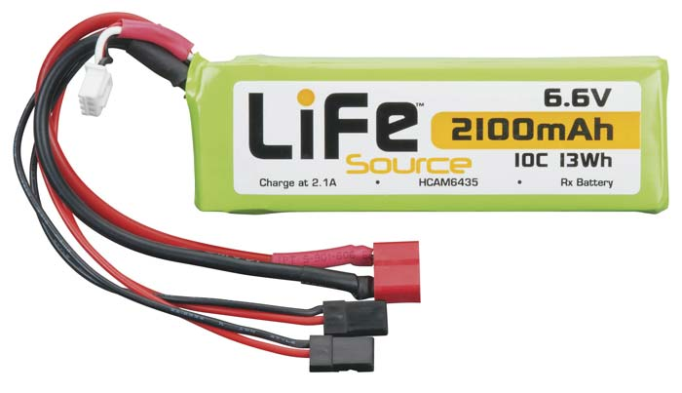

Figure 1: 6.6V LiFePO4 Battery

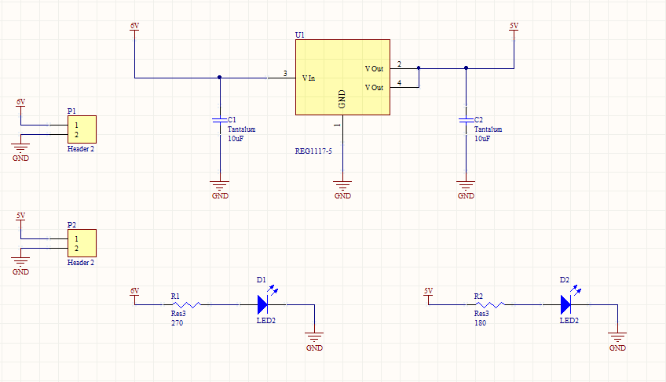

Figure 2: Power Schematic Revision 1

The first revision of the power system, shown in Figure 2, utilizes a single linear regulator with two decoupling capacitors. Status LEDs are added to the Vin and Vout rails of the power supply to provide a visual indication of an input voltage present and output voltage prepared for use. Figure 3 shows the first revision of the power supply PCB. P1 is the input supplied by the lithium iron phosphate battery via a Deans Ultra Plug. P1 is the output of the power supply and uses a DC barrel jack to connect to the Beagle Bone.

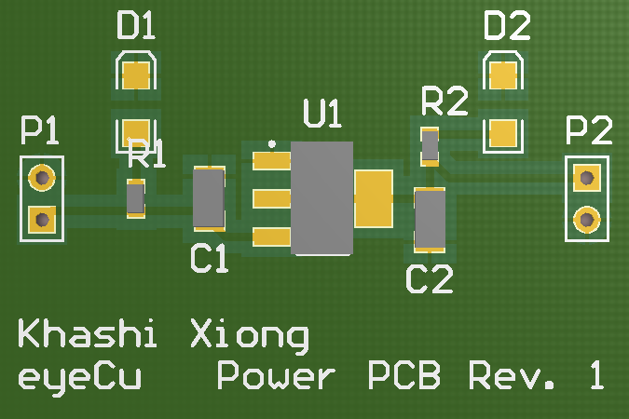

Figure 3: Power Supply PCB Revision 1

The second revision of the power supply utilizes the same circuit as the first revision power supply, but the second revision power supply also includes a recharging circuit capable of recharging the lithium iron phosphate battery. The charge controlling integrated circuit is a BQ2057 from Texas Instruments and utilizes a PNP transistor, decoupling capacitors, and a charging LED. When the battery is fully charged the charging LED turns off. Figure 4 shows the second revision power supply with battery recharging circuit.

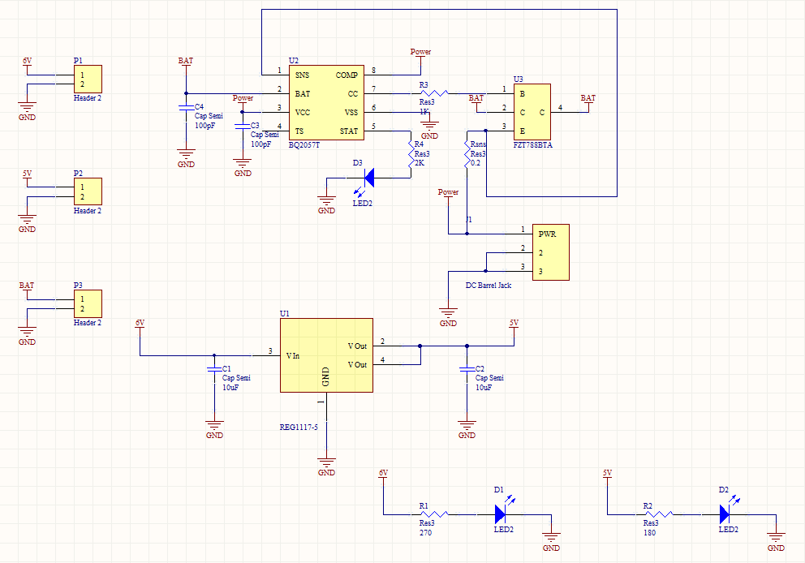

Figure 4: Power Schematic Revision 2

Figure 5 shows the second revision PCB. Power for the recharging circuit takes an input DC power supply through J1 and outputs through a Deans Ultra Plug via P3.

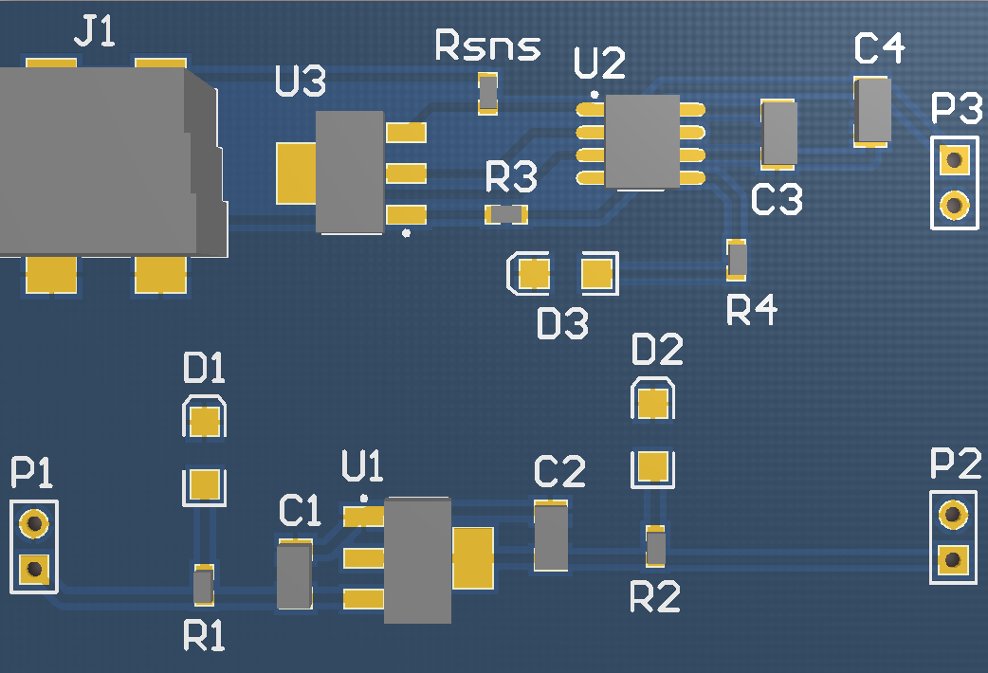

Figure 5: Power PCB Revision 2

Figure 6 shows the flowchart for the recharging circuit.

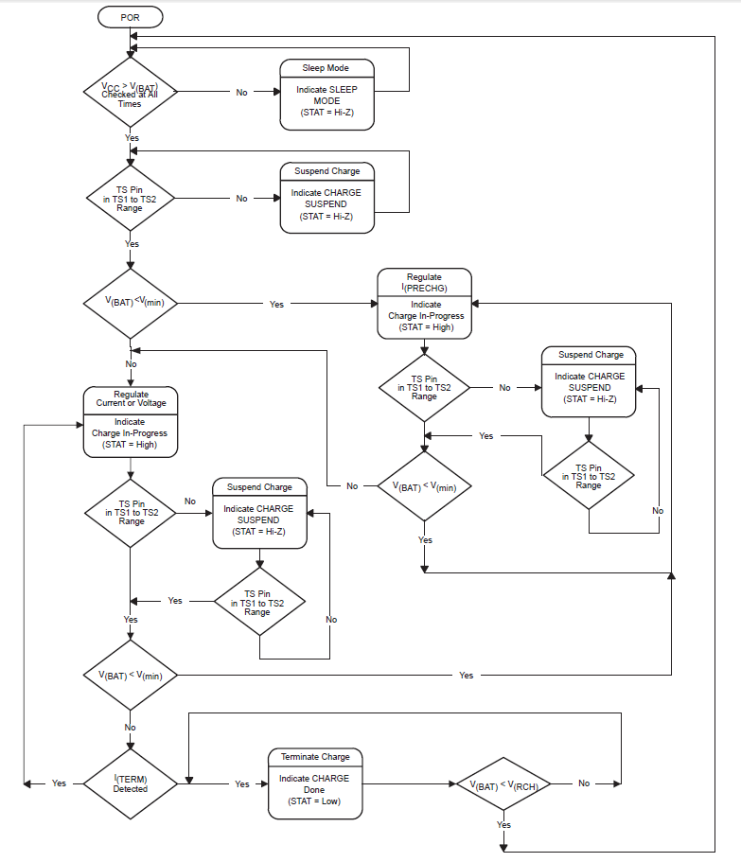

Figure 6: Recharging Circuit Flowchart